Database Change Work Instruction

Purpose
The purpose of this work instruction is to detail the process of how changes to databases are created and applied.
The scope of this process includes:
- Changes in existing database structure (additions, deletions, modifications of tables, or fields)
- Changes in data itself such as data patches.

Assumptions made in this work instruction are:
- All the database changes must come from a change request, an assigned bug fix, or a product enhancement defined in an approved design document.
- An impact analysis of the changes (to both database and source code) must be performed in the design process prior. A Unit Test plan will be created inline with the design document to unit test both code and database changes. Refer to Design Work Instruction and the Unit Testing Work Instruction for more information
- The database changes may be accompanied by a change in source code. Please see Coding Process Work Instruction for more details.
- It is the responsibility of the developer to test the database changes and the modified version of source code before passing to the Database Administrator (DBA).

Instructions

Flowchart
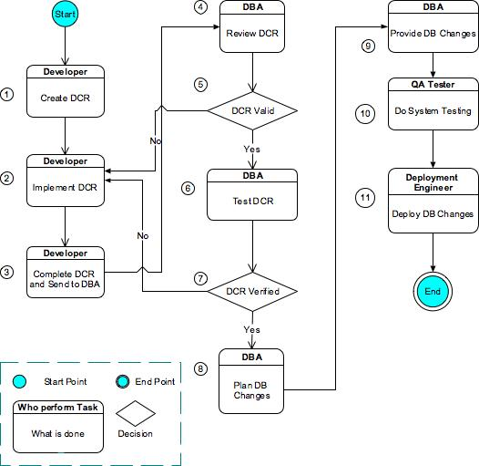

Figure 2.1 Database Change Process

Instruction Description

Instruction Description – Initial Coding Process
Task # | Task Name | Instruction | Responsibility
1 | Create Database Change Request | The developer obtains a copy of DCR template and fills in relevant information based on the design document and impact analysis. | Developer
2 | Implement Database Change | Implement database change as specified in the design document or change request (Refer to the Design Process Work Instruction). | Developer
3 | Complete the DCR and send to the DBAs | The developer completes the DCR form with the actual SQL statements and changes. The completed form is sent the DBA team. The DCR will be allocated to one of the DBAs to address. | Developer
4 | Review DCR | Based on the documents given by the Developer, the DBA will analyze the impact of changes..  The DCR is reviewed against the following criteria:  - Clarity of instructions and plans  - Provision of all required SQL patch files  - The change correctly addresses the target design or change request\  - The change maintains the integrity of database across multiple clients and the base product  - The change is appropriate for the product | DBA
5 | Is DCR Valid? | If the review criteria are met, then DBA approves changes. Proceeds to Step 6.  If the review criteria are not met then issues are presented to the Developer. Return to Step 2. | DBA
6 | Test Database Changes | Once implemented and DCR approved the change needs to be unit tested along with the accompanying source code in accordance with the unit test plan (Refer to the Unit Testing Work Instruction).  Ensure the DBA is present for the code review (Refer to the Code Review Work Instruction) | DBA, Developer,
7 | Did Changes Pass Unit Testing? | If the unit testing was successful then check in the change to the repository and proceed to Step 8 else return to Step 2 for correction | DBA
8 | Plan DB changes | Once the changes have been verified, depending on their scope and impact, they will be incorporated into DBA changes management. The DBA co-ordinates with Deployment Engineer to build up a plan of how and these changes will take effect. | DBA
9 | Provides DB Changes | Once the new deployment is due, the Deployment Engineer sends out an email requesting the database. The DBA compiles all the changes and provide them to the Deployment Engineering. | DBA
10 | Do System Testing | Tests the system based on system test plan, making sure the DB changes functioning correctly. Refer to System Testing Work Instructions | QA tester
11 | Deploy DB changes | After going through the test round, the new changes are ready for deployment. The Deployment Engineer tags the source code, and request database changes from DBA and deploys.

Roles
Refer to the QA Roles and Responsibilities Procedure that lists all the valid roles, and their responsibility.

Definitions
DBA | Database Administrator who is responsible for maintaining product database integrity
DCR | Database Change Request
QA | Quality Assurance
WI | Work Instruction

References
Document Number | Work Instruction Title
NEU-XXX-YYY000 | Review and Approval Work Instruction
NEU-XXX-YYY000 | Document Numbering Work Instruction
NEU-XXX-YYY000 | QA Roles and Responsibilities Procedure
NEU-TEC-WI001 | Design Process Work Instruction
NEU-TEC-WI007 | System Testing Work Instruction
NEU-TEC-WI002 | Coding Process Work Instruction
NEU-TEC-WI003 | Unit Testing Work Instruction
NEU-TEC-WI005 | Code Review Work Instruction

Change History
Version | Change | Author | Date
0.1 | Initial Draft Version | Phan Le | 5 December 2005
0.2 | Updates | Seena Parappat | 9 December 2005
0.3 | More updates on DB change deployment | Phan Le | 14 December 2005

